
Proposal and Quotation for E-Commerce Seller Account Services
https://www.veloxn.com
Introduction -
Thank You for showing interest in E-Commerce Seller Account Services with Veloxn Private Limited.
Service Cost -
The table below details the cost associated with this service.
Name | Unit Price | Months | Subtotal
Zepto Seller account | ₹10,000 | 2 | ₹10,000
Blinkit Seller account | ₹10,000 | 2 | ₹10,000
After that rupees each product 4000 per Month
TOTAL |  |  | ₹20,000
GST @ 18% |  |  | ₹3,600
TOTAL Including GST |  |  | ₹23,600

Payment required is ₹23,600
Note* - Offer Valid for 7 Days only

Bank Details:

VELOXN PRIVATE LIMITED
AC Number – 259958439076
IFSC Code – INDB0000702
Bank Name – Indusind Bank
UPI ID - veloxnservices@okicici
QR Code – 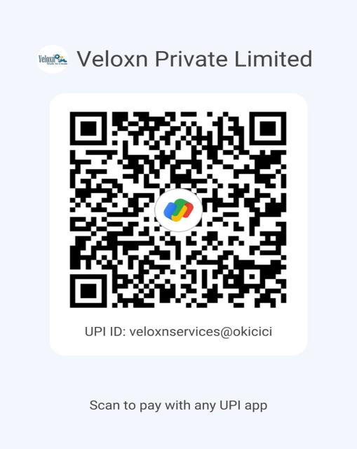

COMPANY:
Veloxn Private Limited
Iconic Tower C, Corenthum, Sector-62, Noida, UP - 201301, India www.veloxn.com
sales@veloxn.com
91-7292001010
GST - 06AAICV7138B1ZE

